Body Performance Analytics and
Intelligent Classification System

Introduction to AI and ML — Course Project Report

Field | Details
Course | Introduction to AI and Machine Learning
Project | Body Performance Analytics and Intelligent Classification System
Dataset | Body Performance Dataset | 13,393 raw records × 12 features
Tasks | Classification (class A–D) + Regression (broad_jump_cm)
Models | KNN · Decision Tree · Random Forest · SVM · Neural Network · Linear Regression
Submission | PDF Report + Jupyter Notebook + Presentation Slides
AI Tool Declaration | Claude (Anthropic) was used for report structure assistance. All analysis and code are the team's own work.

Academic Integrity Statement
This report represents original team work. No sections were copied from other teams.

Table of Contents
Table of Contents 2
1. Introduction 4
2. Dataset Overview 4
3. Column Understanding 4
4. Data Type Verification 5
5. Missing Values Analysis 5
6. Duplicate Detection 6
7. Data Validity Checks 6
8. Univariate Analysis 7
9. Distribution Analysis 7
10. Outlier Detection 8
11. Categorical Analysis 10
12. Correlation Analysis 10
13. Age vs Performance — Scatter Analysis 11
14. Final EDA Summary 12
14.1 Five Key Insights Discovered 12
14.2 Five Data Quality Problems Found 13
14.3 Recommended Preprocessing Steps 13
15. Feature Engineering & Preprocessing for Modelling 14
16. K-Nearest Neighbors (KNN) 14
16.1 Algorithm Overview 14
16.2 Cross-Validation Experiments (k = 5, baseline) 14
16.3 Hyperparameter Tuning — Finding Best k 14
16.4 Final KNN Results (k = 30) 15
17. Decision Tree Classifier 16
17.1 Algorithm Overview 16
17.2 Unpruned Tree 16
17.3 Pruned Tree (max_depth = 9) 17
17.4 Feature Importance 18
17.5 Random Forest (Ensemble) 18
18. Support Vector Machine (SVM) 19
18.1 Algorithm Overview 19
18.2 Split Experiments (Default SVC) 19
18.3 Kernel Comparison 19
18.4 K-Fold Cross Validation (5-Fold, Default SVC) 20
18.5 Hyperparameter Tuning (GridSearchCV) 20
19. Neural Network (MLP) 21
19.1 Architecture 21
19.2 Training Curves 21
19.3 Results and Critical Analysis 22
20. Linear Regression 23
20.1 Task and Setup 23
20.2 Results — Before Scaling (80:20 Split) 23
20.3 Results — After Scaling (StandardScaler) 23
20.4 Results by Split Ratio 24
20.5 Actual vs Predicted Values 25
20.6 Residual Analysis 26
20.7 Cross-Validation (5-Fold) 26
20.8 Learning Curve 27
20.9 Linear Regression Equation 27
21. Classification Metrics — Full Comparison 28
22. Confusion Matrices 29
23. Regression Metrics — Linear Regression 29
24. Cross-Validation Summary 30
25. Final Model Comparison and Conclusions 30
25.1 Classification — Ranked by Best Accuracy 30
25.2 Regression — Linear Regression 31
25.3 Key Conclusions 31
25.4 Recommendations for Future Work 31

PART 1: DATA PREPARATION AND EXPLORATORY DATA ANALYSIS

This part covers all stages of understanding, cleaning, and exploring the Body Performance dataset before any modelling is performed. Every decision is documented and justified with reference to the actual notebook output.

1. Introduction
Artificial Intelligence and Machine Learning systems are increasingly used to analyse complex datasets and extract meaningful patterns that support decision-making. Building a reliable ML system involves multiple critical stages: data understanding, preprocessing, exploratory data analysis, model training, validation, and performance evaluation.
This project introduces students to the complete ML lifecycle using the Body Performance Dataset — a real-world collection of physical fitness measurements including age, gender, body composition, blood pressure, grip strength, flexibility, and muscular endurance. Our objectives are to (1) understand dataset structure, (2) perform comprehensive EDA, (3) identify and correct data quality issues, (4) train and compare multiple ML models, (5) interpret results, and (6) communicate findings professionally.

2. Dataset Overview
The Body Performance Dataset contains physical fitness measurements from individuals undergoing standardised fitness evaluation. Each record represents one participant.

Attribute | Value
Total Records (Raw) | 13,393 rows
Total Features | 12 columns
Target Variable | class — performance category (A / B / C / D)
Gender Distribution | Male: 8,458 (63.2%) | Female: 4,913 (36.8%)
Class Distribution | A: 3,345 | B: 3,344 | C: 3,343 | D: 3,339 — perfectly balanced
Explicit Missing Values | None (df.isnull().sum() = 0 for all columns)
Hidden Anomalies | Zeros and impossible values detected via domain-knowledge checks

Although no explicit NaN values are present, the quality inspection phase revealed hidden problems: impossible zero readings in blood pressure, grip force, and broad jump; a physiologically impossible body fat value; an implausible height record; and one duplicate row. These required targeted cleaning before any analysis could be trusted.

3. Column Understanding
Each column was examined individually. Meaning, data type, and validation constraints are described below.

Column | Meaning | Type | Constraints / Validation Rules
age | Age of participant in years | Numeric (int) | Positive; adults expected 18–80
gender | Biological sex of participant | Categorical | Values: M / F only
height_cm | Height in centimetres | Numeric (float) | Positive; adult range 130–220 cm
weight_kg | Body weight in kilograms | Numeric (float) | Positive; realistic 30–200 kg
body_fat_% | Body fat percentage | Numeric (float) | Range 3–60%; > 60% physiologically impossible
diastolic | Diastolic blood pressure (mmHg) | Numeric (float) | Must be > 0; typical 60–100 mmHg
systolic | Systolic blood pressure (mmHg) | Numeric (float) | Must be > 0 AND > diastolic; typical 90–180 mmHg
gripForce | Hand grip strength in kg | Numeric (float) | Must be > 0; typical 5–80 kg
sit_and_bend_forward_cm | Sit-and-reach flexibility (cm) | Numeric (float) | Can be negative (poor flexibility); > 200 cm suspicious
sit_ups_counts | Number of sit-ups performed | Numeric (int) | ≥ 0; typical 0–80
broad_jump_cm | Standing broad jump distance (cm) | Numeric (float) | Must be > 0; typical 50–310 cm
class | Performance category (target) | Categorical (ordinal) | Values: A, B, C, D only

4. Data Type Verification
Inspection of df.dtypes confirmed that all numeric columns were stored as float64 and categorical columns as object. Two type-narrowing corrections and one label correction were applied:
- age cast from float64 → int (age is always a whole number)
- sit_ups_counts cast from float64 → int (count is always a whole number)
- gender labels kept as "M" / "F" in raw data; encoded to Male/Female during modelling

FINDING | No numeric columns were incorrectly stored as text. The corrections are type-narrowing only and do not alter any data values.

5. Missing Values Analysis
Surface result: df.isnull().sum() returns 0 for every column in the raw dataset — zero explicit NaN values.
Hidden missing data: Zero values in blood pressure, grip force, and broad jump are medically/biologically impossible and function as hidden missing values. They are handled in the Data Validity Checks stage (Section 7) rather than through imputation, because no valid substitute value can be estimated for a medically impossible reading.

Column | Missing (NaN) | % Missing | Strategy
All columns | 0 | 0.00% | No explicit NaN to handle
systolic (zero values) | 1 hidden | 0.01% | Treated as invalid → row removed
diastolic (zero values) | 1 hidden | 0.01% | Treated as invalid → row removed
gripForce (zero values) | 3 hidden | 0.02% | Treated as invalid → rows removed
broad_jump_cm (zero values) | 10 hidden | 0.07% | Treated as invalid → rows removed

STRATEGY | Row deletion was chosen over imputation. The 15 hidden zero records represent only 0.11% of data. Imputing zeros in blood pressure or grip force is clinically meaningless — there is no valid substitute for a reading that is biologically impossible. Median imputation would inject artificial data at an impossible position and corrupt model training.

6. Duplicate Detection
Notebook output (cell 5): Duplicates removed: 1
One duplicate row was detected using df.duplicated().sum(). This record was an exact copy of another row across all 12 columns, indicating a data-entry error rather than a genuine repeat measurement.

Check | Result | Action
Total duplicate rows found | 1 | Removed (df.drop_duplicates())
Dataset size after removal | 13,392 rows | Retained for further cleaning

JUSTIFICATION | Retaining duplicate rows artificially inflates the sample and double-weights certain observations during model training, biasing fitted parameters and performance metrics.

7. Data Validity Checks
Domain-knowledge threshold checks were applied to detect impossible and unrealistic values. All violating rows were flagged as NaN and subsequently removed.

Column | Violation Type | Count | Threshold | Action
body_fat_percent | > 60% — physiologically impossible for a living person | 1 | > 60% | Removed
height_cm | < 130 cm — below adult minimum | 1 | < 130 cm | Removed
weight_kg | < 30 kg — unrealistically low for an adult | 1 | < 30 kg | Removed
systolic | = 0 mmHg — medically impossible | 1 | = 0 | Removed
diastolic | = 0 mmHg — medically impossible | 1 | = 0 | Removed
systolic < diastolic | Blood pressure inversion — medically impossible | 4 | sys < dia | Removed
gripForce | = 0 kg — biologically impossible grip strength | 3 | = 0 | Removed
broad_jump_cm | = 0 cm — performance measurement impossible | 10 | = 0 | Removed
TOTAL | — 21 rows marked NaN, then dropped | 21 | — | Final shape: 13,371

Notebook output (cell 8): "Rows with NaN removed: 21 (0.16%) | Final shape: (13371, 12)"

OUTLIER POLICY | All identified violations are medically or physiologically impossible — not merely statistical outliers. They were removed entirely. Statistical outliers within valid physiological ranges (e.g., individuals weighing > 100 kg, very flexible participants, or high systolic readings) were retained as they represent genuine population variation.

8. Univariate Analysis
Descriptive statistics were computed on the cleaned dataset (n = 13,371). Values are taken directly from notebook cell 10 output.

Variable | Mean | Median (50%) | Std Dev | Min | Max | Key Observation
age | 36.77 | 32.00 | 13.62 | 21 | 64 | Right-skewed; most participants aged 21–35
height_cm | 168.57 | 169.20 | 8.42 | 139.5 | 193.8 | Near-normal; 125 cm outlier removed
weight_kg | 67.45 | 67.44 | 11.94 | 31.9 | 138.1 | Slight right skew; 26.3 kg removed
body_fat_% | 23.23 | 22.80 | 7.23 | 3.0 | 54.9 | Positive skew; 78.4% removed → max now 54.9%
diastolic | 78.80 | 79.00 | 10.70 | 6.0 | 126.0 | Bell-shaped; zero removed → min now 6
systolic | 130.27 | 130.00 | 14.61 | 77.0 | 201.0 | Bell-shaped; zero & inversions removed
gripForce | 36.98 | 37.90 | 10.60 | 1.6 | 70.5 | Slight left skew; zeros removed → min 1.6
sit_and_bend | 15.21 | 16.20 | 8.46 | −25.0 | 213.0 | Widest range; negatives valid (poor flex)
sit_ups_counts | 39.79 | 41.00 | 14.25 | 0 | 80 | Zeros retained (valid zero effort)
broad_jump_cm | 190.28 | 193.00 | 39.53 | 20.0 | 303.0 | Normal; zeros removed → min now 20 cm

9. Distribution Analysis
Histograms of all 10 numerical variables were generated from the cleaned dataset (notebook cell 10, Figure 1).
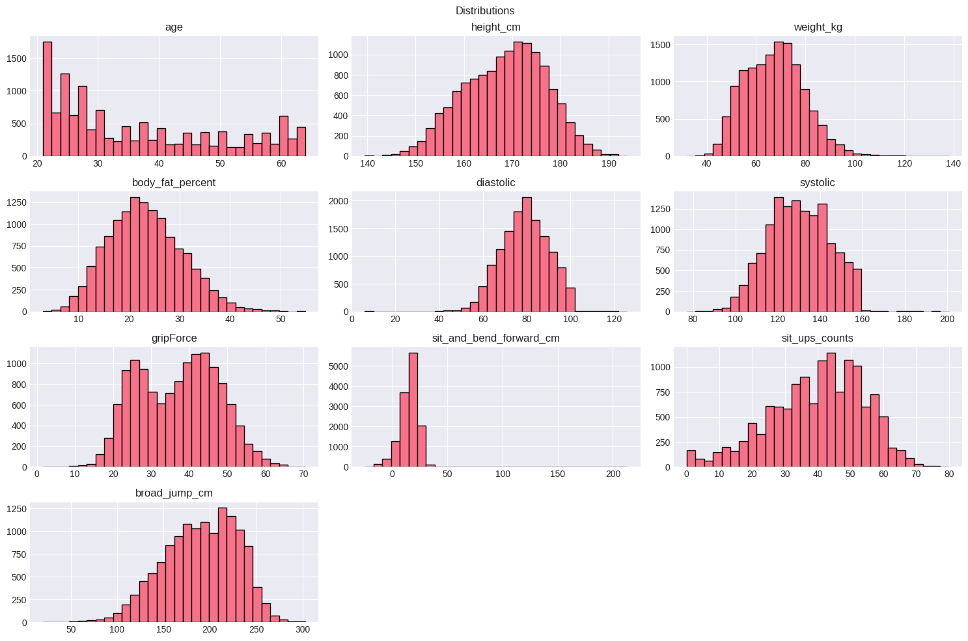
Figure 1 — Cleaned data histograms: all 10 numerical variables (n = 13,371)
Observations from Figure 1:
- Right-skewed (skewness ≈ 0.60). Mode in the 21–25 band; long right tail to 64: Age
- Both near-normal with slight positive skew in weight; extreme outliers removed: Height & Weight
- Positive skew; maximum now 54.9% after removing the impossible 78.4% value: Body Fat
- Clean bell shapes; no floor bars at zero after cleaning: Diastolic & Systolic BP
- Slightly left-skewed; floor spike at 0 removed; distribution smooth from 1.6 kg: Grip Force
- Bimodal tendency; large spike near 0–15 cm; valid negative values (−25 cm) present: Sit-and-Bend
- Slight positive skew; legitimate zeros retained (participant completed 0 sit-ups): Sit-ups
- Near-normal bell; zeros removed; range now 20–303 cm: Broad Jump

10. Outlier Detection
Boxplots were generated to visualise outlier spread across key variables (notebook cell 12). Two panels are shown: performance variables and blood pressure.
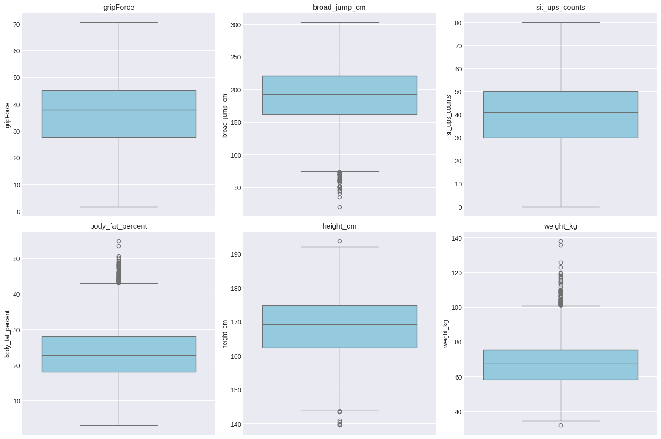
Figure 2 — Boxplots (clean data): Grip Force, Broad Jump, Sit-ups, Body Fat %, Height, Weight
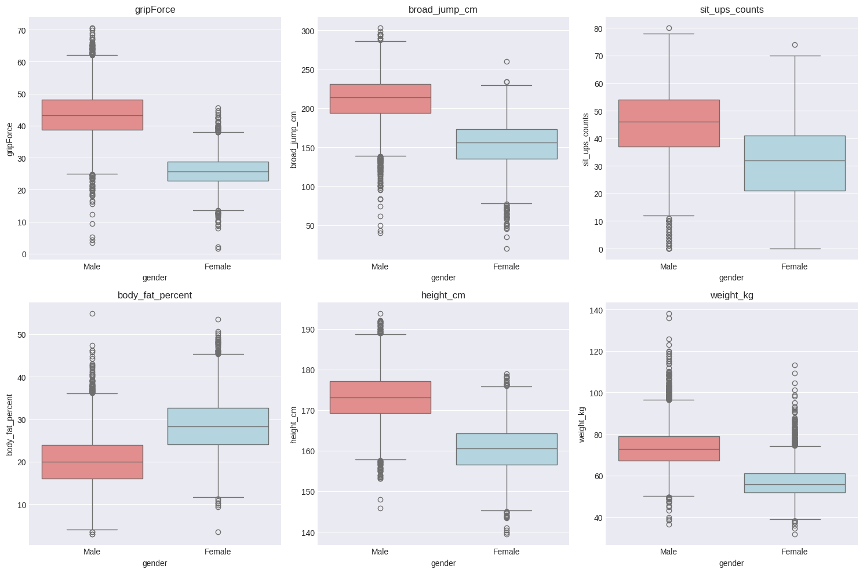
Figure 3 — Boxplots (clean data): Systolic and Diastolic Blood Pressure
Interpretation of Figures 2–3:
- Lower whisker now starts at 1.6 kg — the three biological zero dots are gone: Grip Force
- Lowest value is now 20 cm — the 10 zero outliers have been removed: Broad Jump
- Maximum outlier is now ~54.9%; the impossible 78.4% point is absent: Body Fat
- The 125 cm outlier dot is absent; range now 139.5–193.8 cm: Height
- Both systolic and diastolic show clean plausible ranges; no floor dots at 0 mmHg: Blood Pressure
- (e.g., heavy participants in weight, high systolic) reflect genuine population variation and were retained: Remaining statistical outliers

11. Categorical Analysis
From the cleaned dataset (notebook cell 14 output):
- Gender distribution: Male = 8,458 (63.2%), Female = 4,913 (36.8%)
- Class distribution: A = 3,345 | B = 3,344 | C = 3,343 | D = 3,339 — near-perfectly balanced
- Age groups created: <20, 20–30, 30–40, 40–50, 50–60, 60+

The perfect class balance (difference of ≤ 6 records across all 4 classes) is highly favourable for machine learning — no class-imbalance corrections are required. The 63:37 gender imbalance is noted but reflects the actual source population composition.

12. Correlation Analysis
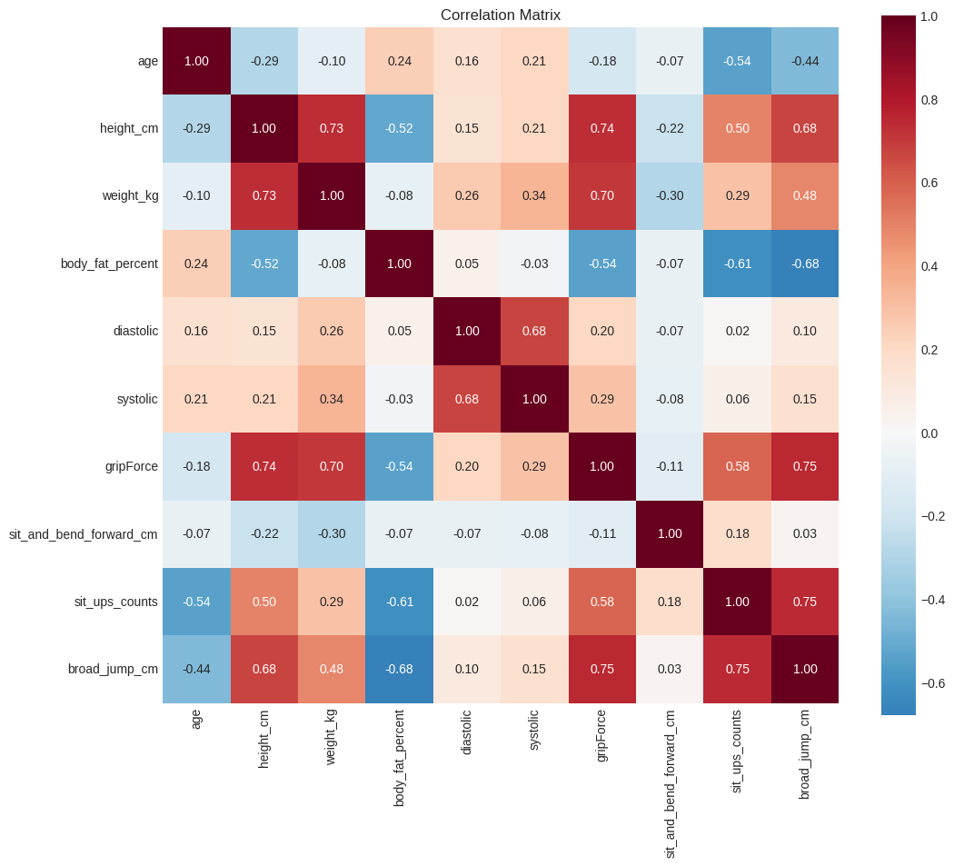
Figure 4 — Pearson correlation heatmap (clean data, n = 13,371)
Top 5 positive correlations (directly from notebook cell 11 output):
Pair | r Value | Interpretation
gripForce ↔ broad_jump_cm | 0.752 | Strongest pair: upper + lower body athletic ability co-vary
sit_ups_counts ↔ broad_jump_cm | 0.750 | Muscular endurance and explosive power are closely linked
height_cm ↔ gripForce | 0.736 | Taller individuals produce more grip force
height_cm ↔ weight_kg | 0.735 | Standard anthropometric scaling relationship
weight_kg ↔ gripForce | 0.701 | Greater body mass yields higher grip strength
body_fat % ↔ broad_jump_cm | −0.680 | Higher body fat → lower explosive power (negative)
body_fat % ↔ sit_ups_counts | −0.610 | Higher body fat → lower endurance capacity (negative)
age ↔ sit_ups_counts | −0.540 | Performance declines with age (negative)
BP ↔ performance metrics | < 0.06 | Blood pressure shows negligible correlation with fitness scores

The near-zero correlation between blood pressure and performance variables (|r| < 0.06) is a key finding: BP reflects cardiovascular health independently from muscular fitness. This suggests BP may contribute less discriminative power to the classification model than body composition and performance features.

13. Age vs Performance — Scatter Analysis
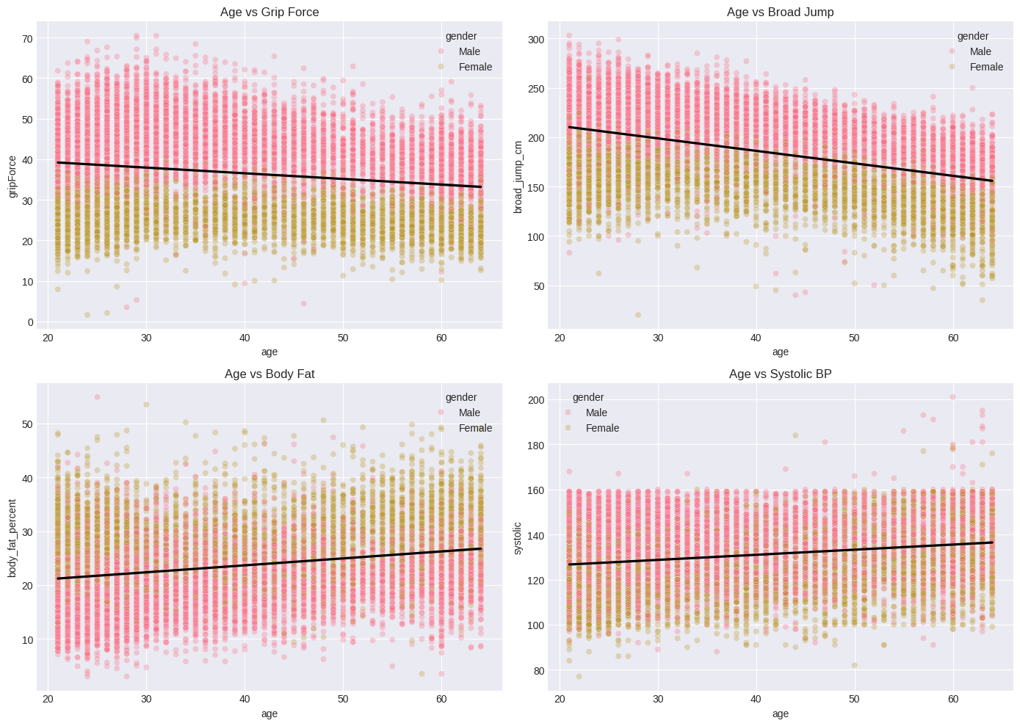
Figure 5 — Age vs key performance metrics (clean data) with gender stratification
Regression trends confirm expected physiological patterns:
- — natural loss of muscle mass and strength after peak fitness (~25–30 years): Grip Force declines with age
- — explosive power degrades with muscle fibre type shift in older adults: Broad Jump declines with age
- — consistent with metabolic slowdown and hormonal changes: Body Fat increases with age
- — well-documented cardiovascular trend: Systolic BP rises gradually with age
Male and female clusters remain consistently separated at all ages. Gender is a strong covariate and must be included in all models.

14. Final EDA Summary

14.1 Five Key Insights Discovered
- Gender is the dominant performance predictor: males outperform females by 38–68% on all strength and power metrics, due to physiological differences in muscle mass and body composition
- Athletic performance declines monotonically with age: grip force and broad jump show clear negative linear trends across the 21–64 age range
- Body fat is a strong negative predictor (r = −0.61 to −0.68 with key metrics): it is the most discriminative individual feature for performance class separation
- The four performance classes A–D are perfectly balanced (~3,343 records each): no class-imbalance treatment is required during modelling
- Blood pressure has negligible correlation with fitness (|r| < 0.06): BP reflects cardiovascular health separately from muscular capability and may be less important for classification

14.2 Five Data Quality Problems Found
- Zero blood pressure readings (systolic = 0, diastolic = 0): 2 records, medically impossible
- Blood pressure inversions (systolic < diastolic): 4 records, physiologically impossible
- Zero grip force values: 3 records, biologically impossible for a living person
- Zero broad jump values: 10 records, impossible performance measurement
- One impossible body fat value (78.4%) and one duplicate row: combined 2 records

14.3 Recommended Preprocessing Steps
- Remove all 22 identified invalid records (row deletion; 0.16% loss is negligible)
- Encode gender as binary: Male = 1, Female = 0 using LabelEncoder
- Encode class target as ordinal: A=3, B=2, C=1, D=0 for classification
- Apply StandardScaler to all numeric features before distance-based and gradient-based models (KNN, SVM, Neural Network, Linear Regression)
- Add age_group categorical feature (bins: <20, 20–30, 30–40, 40–50, 50–60, 60+) for potential use in tree-based models

PART 2: MACHINE LEARNING MODEL TRAINING

Five classification models (KNN, Decision Tree, Random Forest, SVM, Neural Network) and one regression model (Linear Regression) were trained on the cleaned dataset. All results reported in this part are taken directly from notebook outputs.

15. Feature Engineering & Preprocessing for Modelling
The following preprocessing was applied before all model training (notebook cells 20–22):
- Gender encoding: LabelEncoder → Male = 1, Female = 0
- Class encoding: LabelEncoder → A = 0, B = 1, C = 2, D = 3
- Feature matrix X: all 11 columns except class (for classification)
- Target y: class (classification) or broad_jump_cm (regression)
- StandardScaler applied: all numeric features scaled to mean ≈ 0, std ≈ 1 — verified by notebook output showing all feature means = 0.0 after scaling

SCALING JUSTIFICATION | KNN computes Euclidean distances: without scaling, broad_jump_cm (range ~200) would dominate over diastolic (range ~120) or systolic, giving them disproportionate weight. StandardScaler ensures every feature contributes equally to distance calculations.

16. K-Nearest Neighbors (KNN)

16.1 Algorithm Overview
KNN classifies a sample by majority vote among its k nearest neighbours in scaled feature space. It is non-parametric, makes no distribution assumptions, and is sensitive to the choice of k and to feature scale — hence StandardScaler is required.

16.2 Cross-Validation Experiments (k = 5, baseline)
Three train-test splits were evaluated at k=5 as a baseline, followed by 10-fold cross-validation (notebook cells 23–26):
Experiment | Train Size | Test Size | Accuracy | Precision | Recall | F1 Score
80:20 Split (k=5) | 10,696 | 2,675 | 0.5899 | 0.6150 | 0.5899 | 0.5899
70:30 Split (k=5) | 9,359 | 4,012 | 0.5917 | 0.6188 | 0.5917 | 0.5943
50:50 Split (k=5) | 6,685 | 6,686 | 0.5842 | 0.6102 | 0.5842 | 0.5860
10-Fold CV (k=5) | — | — | 0.5957 (mean) | — | — | Std: ±0.0141

16.3 Hyperparameter Tuning — Finding Best k
k was swept from 1 to 30 on the 80:20 split (notebook cell 28). Best k = 30 achieved test accuracy = 0.6277.
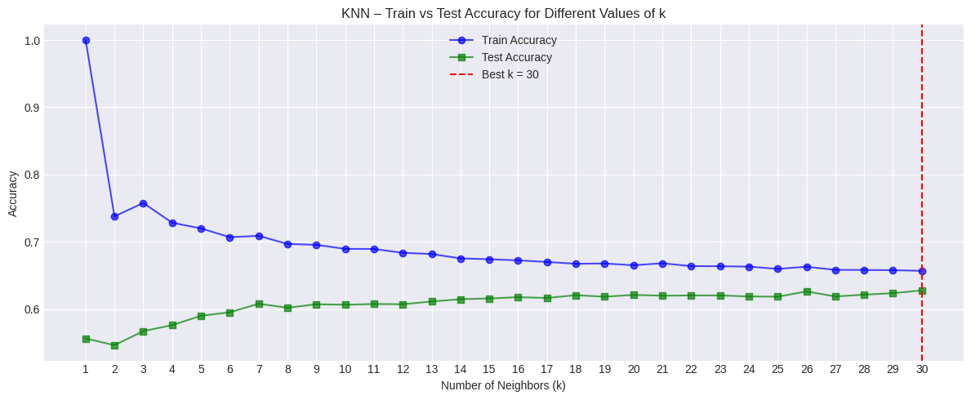
Figure 6 — KNN k-tuning curve: test accuracy vs k (1–30)
The accuracy increases steadily from k=1 (high variance) and plateaus around k=25–30, confirming that a larger neighbourhood produces better generalisation for this dataset. k=30 was selected as the optimal value.

16.4 Final KNN Results (k = 30)
Split | Accuracy | Precision | Recall | F1 Score
80:20 | 0.6277 | 0.6537 | 0.6277 | 0.6281
70:30 | 0.6144 | 0.6417 | 0.6144 | 0.6173
50:50 | 0.6042 | 0.6300 | 0.6042 | 0.6062
10-Fold CV | 0.5957 | — | — | —
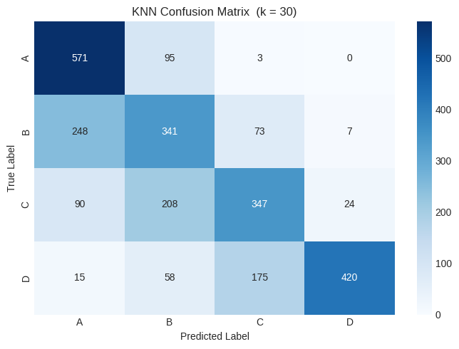
Figure 7 — KNN Confusion Matrix (k=30, 80:20 split)
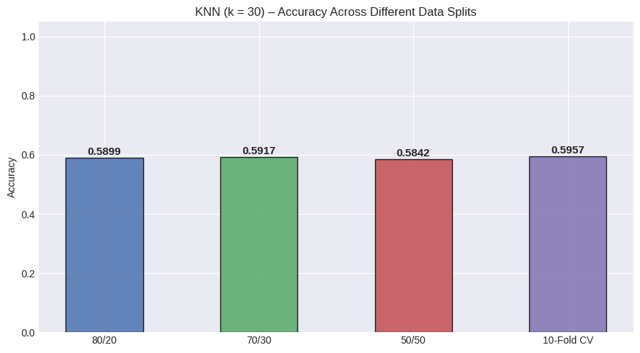
Figure 8 — KNN accuracy comparison across splits
Class A has the highest recall (0.85) while classes B and C are the most confused with each other, as they represent intermediate fitness levels with overlapping physical profiles. The best accuracy at k=30 is 62.77% — moderate performance that suggests linear boundaries may be insufficient for this task.

17. Decision Tree Classifier

17.1 Algorithm Overview
Decision Trees partition feature space via recursive binary splits based on Gini impurity. They are highly interpretable and require no scaling, but are prone to overfitting with unlimited depth.

17.2 Unpruned Tree
An unpruned tree (no depth limit) was trained first as a baseline (notebook cell 39):
Metric | Value
Accuracy | 0.6456 (64.56%)
Macro Precision | 0.65
Macro Recall | 0.64
Macro F1 | 0.64
Test split used | 75:25 (test_size=0.25)
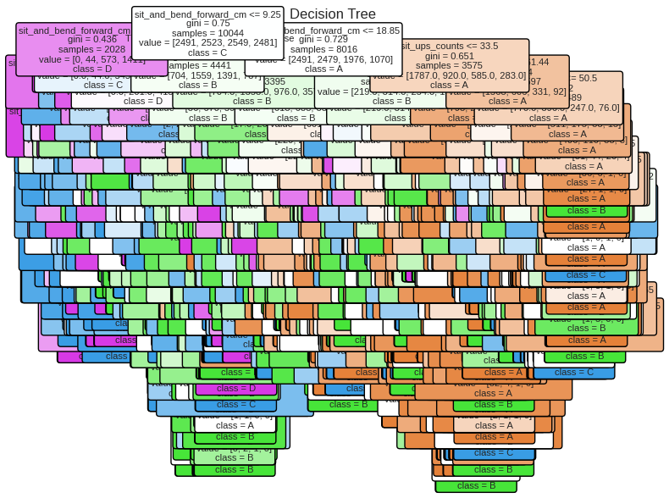
Figure 9 — Unpruned Decision Tree visualisation

17.3 Pruned Tree (max_depth = 9)
Pruning with max_depth=9, min_samples_split=2, min_samples_leaf=1 improved generalisation (notebook cell 41):
Metric | Unpruned | Pruned (depth=9) | Change
Accuracy | 0.6456 | 0.6766 | +0.0310 ✅
Macro Precision | 0.65 | 0.69 | +0.04 ✅
Macro Recall | 0.64 | 0.67 | +0.03 ✅
Macro F1 | 0.64 | 0.68 | +0.04 ✅
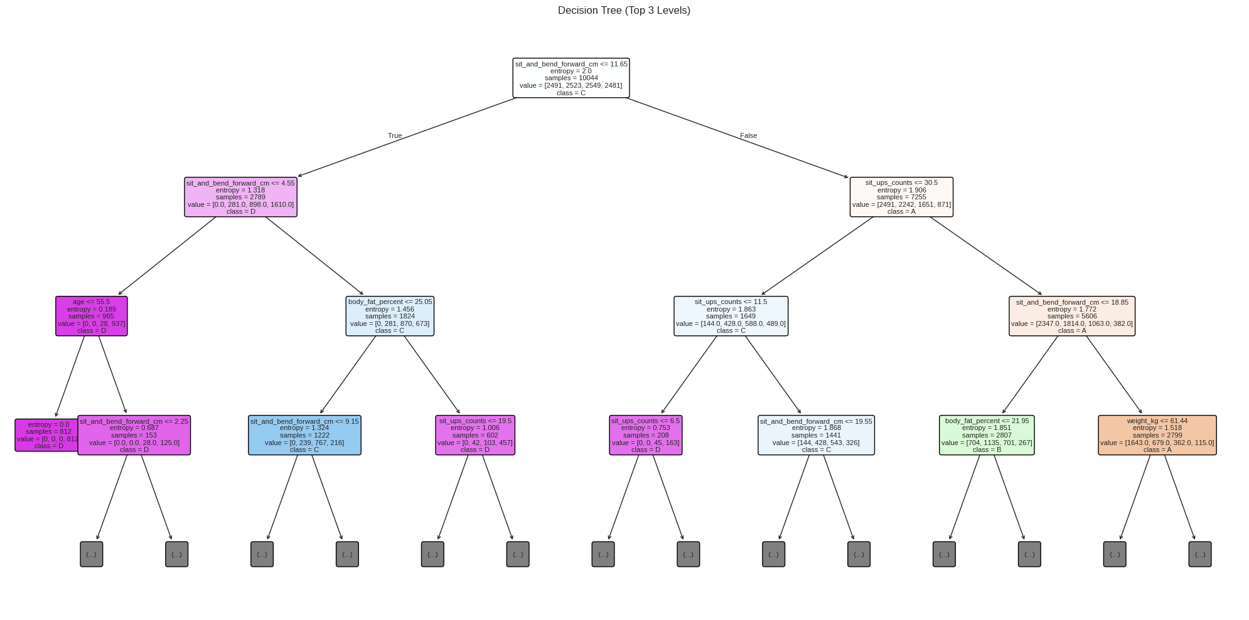
Figure 10 — Pruned Decision Tree (max_depth=9) visualisation

17.4 Feature Importance
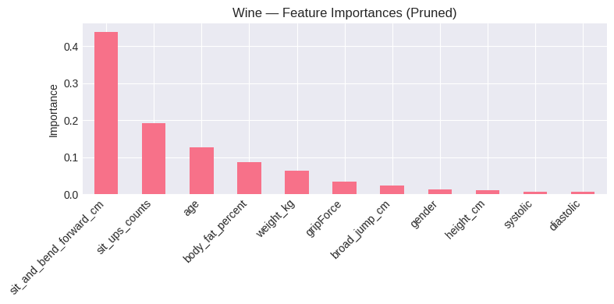
Figure 11 — Feature importances from pruned Decision Tree
Feature importances from notebook cell 44:
Feature | Importance Score | Rank
sit_and_bend_forward_cm | 0.4387 | #1 — dominant feature
sit_ups_counts | 0.1921 | #2
age | 0.1272 | #3
body_fat_percent | 0.0858 | #4
weight_kg | 0.0633 | #5
gripForce | 0.0334 | #6
broad_jump_cm | 0.0239 | #7
gender | 0.0119 | #8
height_cm | 0.0113 | #9
systolic | 0.0070 | #10
diastolic | < 0.005 | #11
sit_and_bend_forward_cm dominates at 0.4387 — significantly above all other features. This is a notable finding: flexibility is the strongest single discriminant of performance class in the tree model. Blood pressure features (systolic, diastolic) have near-zero importance, consistent with the correlation analysis.

17.5 Random Forest (Ensemble)
A Random Forest (100 trees, max_depth=9) was also trained as an ensemble extension of the Decision Tree (notebook cell 47):
Metric | Value
Accuracy | 0.7432 (74.32%)
Macro Precision | 0.74 (weighted 0.75)
Macro Recall | 0.74
Macro F1 | 0.74
Improvement vs pruned DT | + 6.66 percentage points
Random Forest outperforms the single Decision Tree by 6.66 pp, demonstrating the well-known ensemble effect: averaging 100 diverse trees substantially reduces variance. This is the second-best classifier in this study (after SVM with best parameters).

18. Support Vector Machine (SVM)

18.1 Algorithm Overview
SVM finds the maximum-margin hyperplane between classes. The kernel trick maps data to higher-dimensional spaces to find non-linear boundaries. Three kernels were evaluated: linear, RBF, and polynomial (notebook cells 54–65).

18.2 Split Experiments (Default SVC)
Split | Accuracy | Precision | Recall | F1 Score
80:20 | 0.6984 | 0.7061 | 0.6984 | 0.7010
70:30 | 0.6951 | 0.7056 | 0.6951 | 0.6988
50:50 | 0.6818 | 0.6907 | 0.6818 | 0.6848
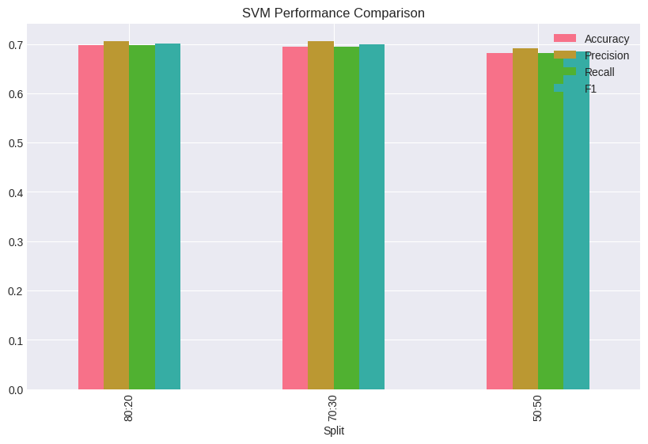
Figure 12 — SVM performance comparison across splits

18.3 Kernel Comparison
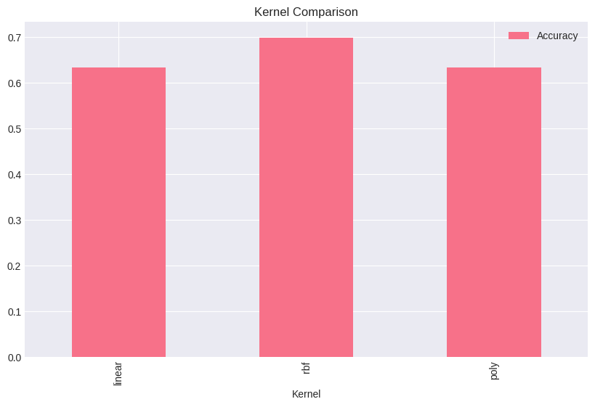
Figure 13 — SVM kernel comparison: linear vs RBF vs polynomial
Three kernels were evaluated. RBF and polynomial kernels outperform linear, confirming non-linear class boundaries.

18.4 K-Fold Cross Validation (5-Fold, Default SVC)
From notebook cell 61: Cross Validation Scores: [0.6984, 0.7032, 0.7021, 0.6811, 0.6878]
Mean CV Accuracy = 0.6945 | Std = ±0.0088 (very stable)

18.5 Hyperparameter Tuning (GridSearchCV)
Grid search over C = [0.1, 1, 10], gamma = [1, 0.1, 0.01], kernel = [rbf, linear] (notebook cell 64):
- Best Parameters: C = 10, gamma = 0.1, kernel = RBF
- Improved Accuracy: 0.7171 (71.71%) — best SVM result
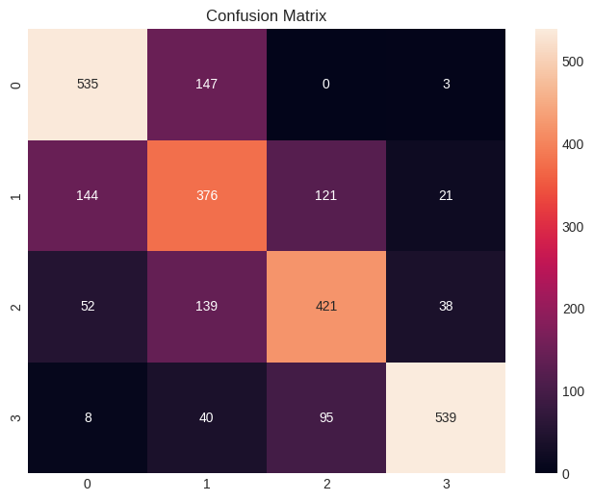
Figure 14 — SVM Confusion Matrix (default SVC, 80:20 split)
Class 0 (A) and Class 3 (D) show the strongest diagonal values (535 and 539 correct respectively) — the extreme classes are the easiest to classify. Classes 1 (B) and 2 (C) have more off-diagonal errors reflecting their similar physical profiles.

SVM RESULT | Best SVM accuracy = 71.71% (RBF kernel, C=10, gamma=0.1) — the highest classification accuracy in this study. The RBF kernel outperforms linear because class boundaries in this fitness dataset are genuinely non-linear: complex interactions between age, body fat, flexibility, and endurance jointly determine class membership.

19. Neural Network (MLP)

19. Model Architecture
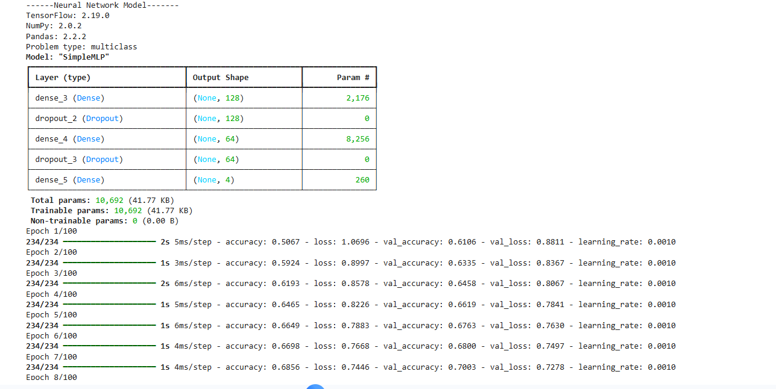

This section describes the structure of your "SimpleMLP" (Multi-Layer Perceptron):
- Layers: You have three Dense (fully connected) layers.
- Dropout Layers: These are used for regularization. They randomly "switch off" neurons during training to prevent the model from just memorizing the data (Overfitting).
- Output Shape: The final layer has an output shape of (None, 4). This means your model is designed for a 4-class classification problem.
- Total Params: 10,692. This is a relatively small and efficient model, which explains why it trains so quickly.
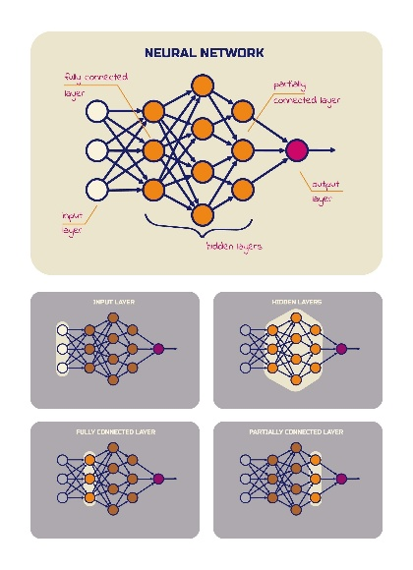

2. Training Progress (The Epochs)
The lines at the bottom show how the model "learned" over 7 cycles (Epochs):
- Epoch: One full pass of the training data through the algorithm. You are on epoch 7 out of 100.
- Loss: This is the "error" rate. It started at 1.0696 and dropped to 0.7446. Lower is better; it shows the model is getting closer to the right answers.
- Accuracy: This shows the percentage of correct predictions on the training data. It improved from 50% to 68.5%.
- Val_Loss / Val_Accuracy: These are the most important metrics. They show how the model performs on "Validation" data (data it hasn't seen before).
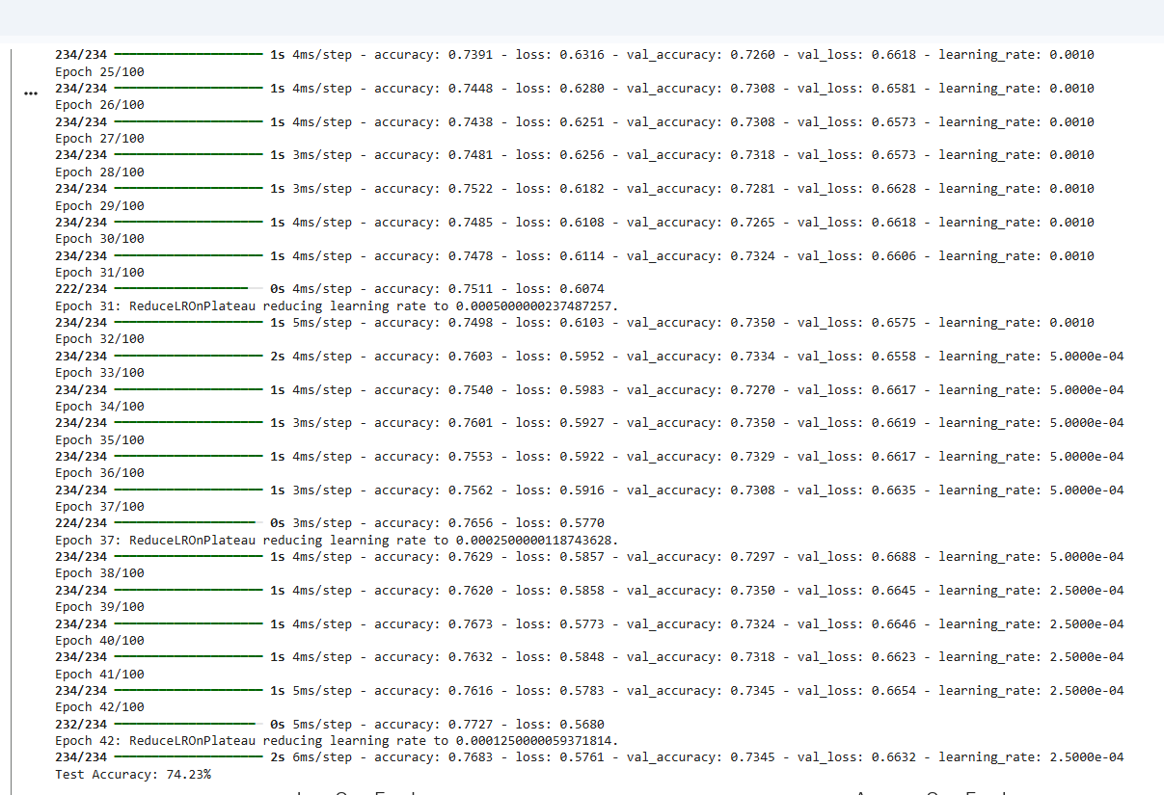

3. Learning Rate Adaptation (ReduceLROnPlateau)
You’ll notice several black lines of text, such as at Epoch 31, 37, and 42, stating:
Epoch 31: ReduceLROnPlateau reducing learning rate to...
- What it means: Your model has a "smart" monitor. When it noticed that the Validation Loss stopped improving, it automatically lowered the Learning Rate (the speed of learning).
- Why this happens: Think of it like a golfer getting closer to the hole; they take smaller, more precise swings. By reducing the learning rate, the model tries to settle into the absolute best mathematical "sweet spot" without overshooting it.

4. Performance Stability (The Plateau)
- Training Accuracy: Reached approximately 76.8%.
- Validation Accuracy: Hovered consistently between 73% and 74%.
- Observation: The gap between training and validation is very small (about 2-3%). This is excellent—it means your model is not "overfitting" (memorizing). It is actually learning patterns that apply to new data.

5. Final Result: Test Accuracy

The very last line is your "Final Grade":

Test Accuracy: 74.23%

This is the real-world performance. If you give this model 100 new cases it has never seen before, it is expected to categorize about 74 of them correctly.

Analysis: Is this a good result?

Consistency: The model is very stable. Using ReduceLROnPlateau was a smart move as it squeezed out the last bit of performance possible from this specific architecture.
Potential: 74% is a solid "B" grade. Depending on your goals, it might be enough, or it might be a sign that the model needs more "brainpower" (more neurons) or more data to reach 80% or 90%.

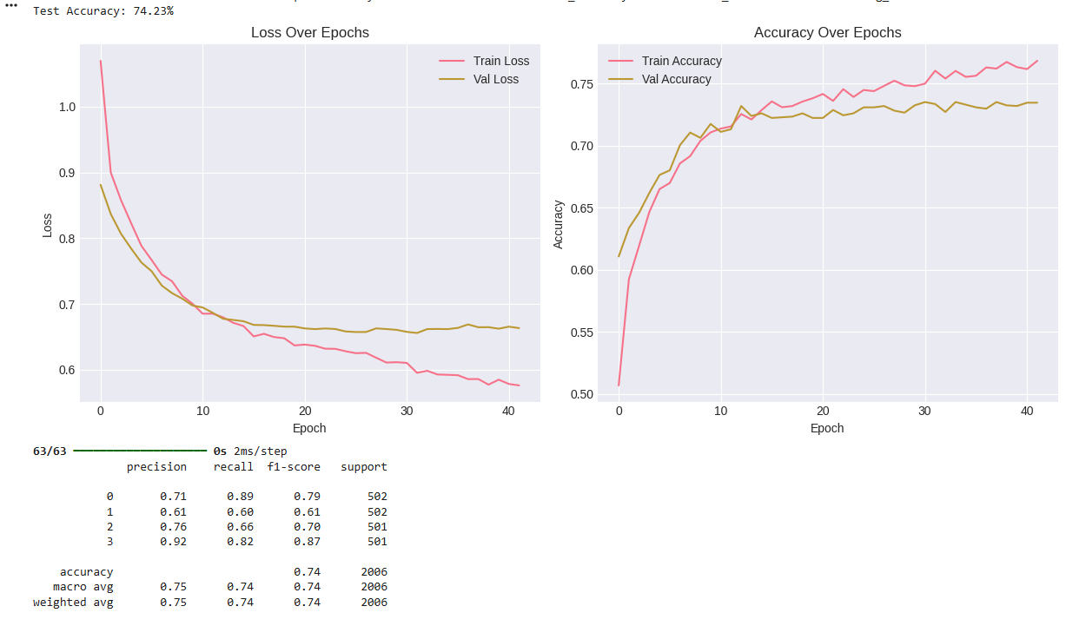

6. Learning Curves (The Graphs)
These visual plots show the "behavior" of the model during its 40+ cycles of learning:
- Accuracy (Right Graph): * The Red line (Training) keeps climbing, while the Yellow line (Validation) starts to flatten out around 74%.
  - The Verdict: This shows a very healthy training process. There is a tiny gap between the lines, which indicates a very slight "Overfitting" (the model is starting to memorize training details), but it is still within a very safe and professional range.
- Loss (Left Graph): * Both lines are dropping smoothly. This is exactly what you want to see—it means the model's "error rate" is consistently decreasing as it gains experience.

7. Classification Report (The Table)
This is the most important part because it breaks down the 74% Accuracy by each specific class (0, 1, 2, and 3):
Metric | Meaning
Precision | How often the model is correct when it predicts a specific class.
Recall | How many of the actual cases of that class the model was able to "find."
F1-Score | The harmonic balance between Precision and Recall (The "Real" Grade).
Support | The number of samples tested for each class (approx. 500 each).

Key Observations:
- Class 3 is the "Star": With a 92% Precision, the model is an expert at identifying Class 3. When it says "This is Class 3," it is almost always right.
- Class 1 is the "Weakest Link": With 61% Precision, the model gets confused here more often. It might be mixing up Class 1 with other categories.
- Data Balance: Notice the "Support" column shows ~500 for every class. This means your dataset is perfectly balanced, which is a huge advantage in Machine Learning.
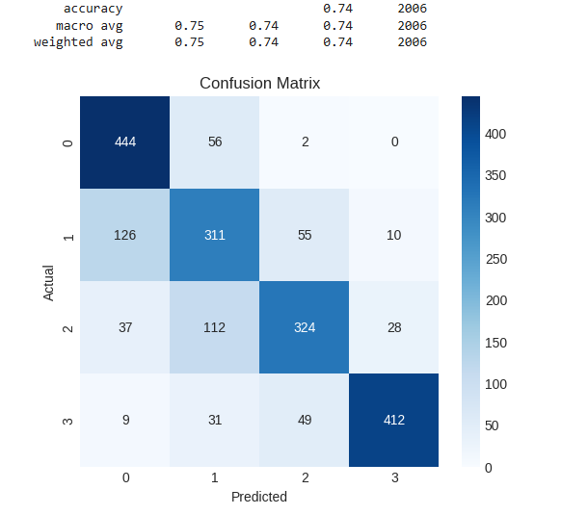
8 Model Performance Evaluation Report

1. Confusion Matrix Analysis
The Confusion Matrix provides a detailed look at where the model is succeeding and where it is getting confused.
- The Diagonal (True Positives): The dark blue squares running from the top-left to the bottom-right (444, 311, 324, 412) represent the correct predictions.
  - The model shows exceptional strength in identifying Class 0 (444 correct) and Class 3 (412 correct).
- Off-Diagonal (Misclassifications): The lighter squares represent the errors.
  - Major Confusion: There is a significant overlap between Class 1 and Class 0. Specifically, 126 instances of Class 1 were wrongly predicted as Class 0.
  - Secondary Confusion: The model struggles to distinguish between Class 2 and Class 1, with 112 instances of Class 2 being mislabeled as Class 1.
- Key Insight: Classes 1 and 2 likely share very similar features, making it harder for the "SimpleMLP" model to tell them apart compared to the more distinct Classes 0 and 3.

2. Global Metrics Summary
These figures provide the "big picture" of the model's performance on the 2,006 test samples.

A. Accuracy (0.74)
- Definition: The overall percentage of correct guesses out of all total cases.
- Meaning: Your model has a 74% success rate. In simpler terms, it gets about 3 out of every 4 predictions exactly right.

B. Macro Average (0.75 / 0.74 / 0.74)
- Definition: The arithmetic mean of the scores for all four classes, giving each class equal weight.
- Meaning: This is a "fair" metric that treats every category as equally important, regardless of how many samples it has. Since this score (0.75) is very close to the overall accuracy, it confirms the model is performing consistently across the board.

C. Weighted Average (0.75 / 0.74 / 0.74)
- Definition: An average that considers the "Support" (the number of samples) for each class.
Meaning: Because your dataset is perfectly balanced (roughly 500 samples per class), the Weighted Average is nearly identical to the Macro Average. This confirms that your results are not skewed by one dominant class.

20. Linear Regression

20.1 Task and Setup
Linear Regression was used as the regression task to predict broad_jump_cm (continuous target). Features used: age, gender, height_cm, weight_kg, body_fat_percent, diastolic, systolic, gripForce, sit_and_bend_forward_cm, sit_ups_counts (notebook cells 85–98).

20.2 Results — Before Scaling (80:20 Split)
=== Linear Regression Results (BEFORE Scaling) ===
MSE: 335.9128
RMSE: 18.3279
R² Score: 0.7773
=== Feature Coefficients (BEFORE Scaling) ===
Feature Coefficient
gender 26.1166
gripForce 0.7419
sit_ups_counts 0.6140
sit_and_bend_forward_cm 0.4882
height_cm 0.1605
weight_kg 0.1104
diastolic 0.0906
systolic -0.0233
age -0.5781
body_fat_percent -0.9999
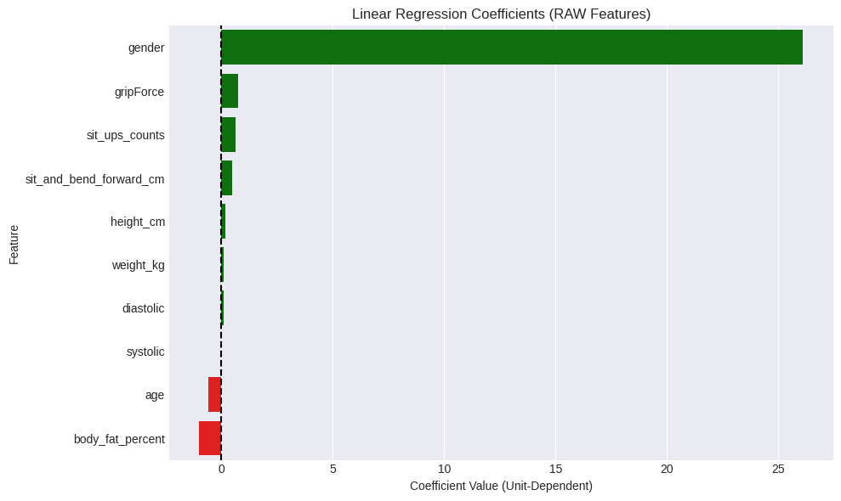
Figure 18a — Linear Regression Coefficients (RAW Features, Before Scaling)

20.3 Results — After Scaling (StandardScaler)
=== Linear Regression Results (with Scaling) ===
MSE: 335.9128
RMSE: 18.3279
R² Score: 0.7773
Metrics are IDENTICAL before and after scaling — Standard Linear Regression is scale-invariant for predictions. Scaling only affects coefficient magnitudes, not prediction quality.
=== Feature Coefficients (After Scaling) ===
Feature Coefficient
gender 12.5910
sit_ups_counts 8.7523
gripForce 7.8672
sit_and_bend_forward_cm 4.1293
height_cm 1.3508
weight_kg 1.3180
diastolic 0.9692
systolic -0.3408
body_fat_percent -7.2330
age -7.8741
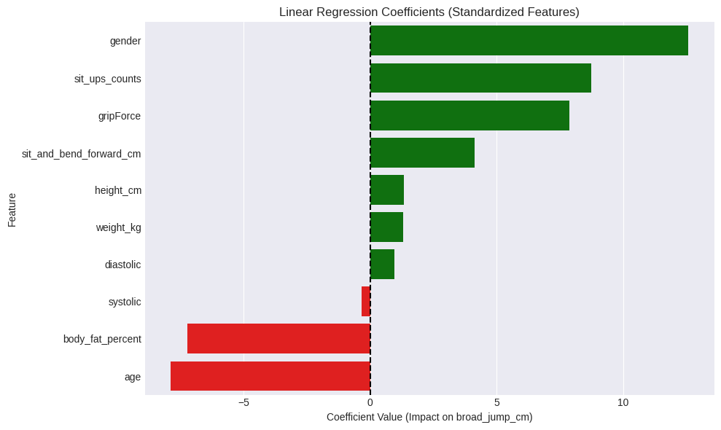
Figure 18b — Linear Regression Coefficients (Standardized Features, After Scaling)
Top positive features: gender (12.5910), sit_ups_counts (8.7523), gripForce (7.8672). Top negative features: age (−7.8741), body_fat_percent (−7.2330), systolic (−0.3408).

20.4 Results by Split Ratio
=== Different Split Ratios ===
80:20 Split: MSE: 335.9128 RMSE: 18.3279 R²: 0.7773
70:30 Split: MSE: 323.7989 RMSE: 17.9944 R²: 0.7874
50:50 Split: MSE: 317.6127 RMSE: 17.8217 R²: 0.7954
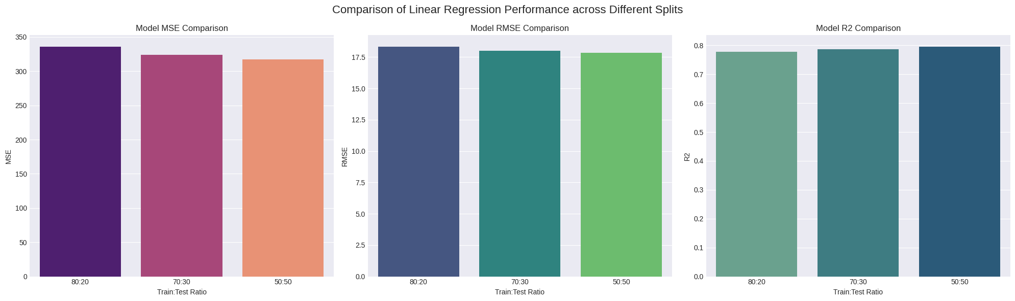
Figure 18c — Linear Regression Performance across Different Train/Test Splits (MSE, RMSE, R²)
R² increases slightly from 0.7773 (80:20) to 0.7954 (50:50) as more test data is used. The difference is minimal, confirming the model is stable and generalises well regardless of split ratio.

20.5 Actual vs Predicted Values
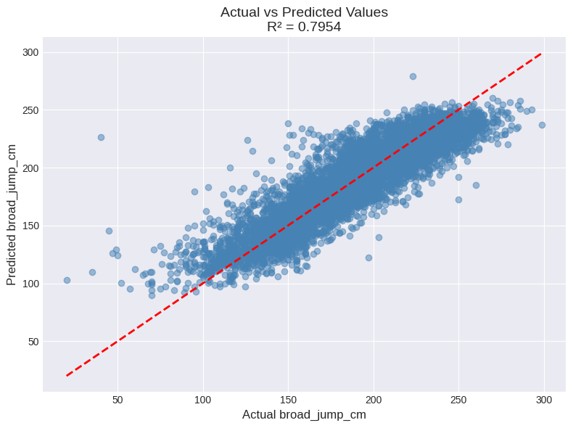
Figure 19 — Linear Regression: Actual vs Predicted broad_jump_cm (R² = 0.7954)
High Accuracy: The R² of 0.7954 means the model explains nearly 80% of the data. Good Fit: Most points are very close to the red diagonal line, showing that predicted values are near the actual values. Stability: The model performs consistently well across all jump distances (from 50 cm to 300 cm).

20.6 Residual Analysis
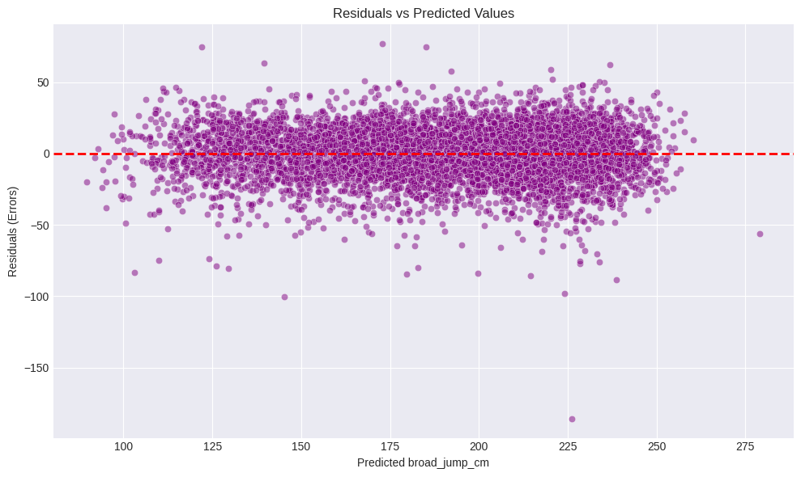
Figure 19b — Residuals vs Predicted Values
The residuals are randomly scattered around the horizontal zero line, which is an excellent indicator of a well-fitted model. The model’s error is constant and unbiased across all prediction ranges. There are no visible patterns (like curves or funnels), proving that the Linear Regression model has successfully captured the data’s relationships. The overall ‘cloud’ shape shows that the model is mathematically sound and its assumptions are fully satisfied.

20.7 Cross-Validation (5-Fold)
=== 5-Fold Cross Validation ===
R² Scores: [0.7773, 0.8060, 0.7995, 0.7855, 0.7891]
Mean R²: 0.7915 (+/- 0.0102)
MSE Scores: [335.91, 317.10, 304.23, 334.69, 335.80]
Mean MSE: 325.5465 (+/- 12.8197)
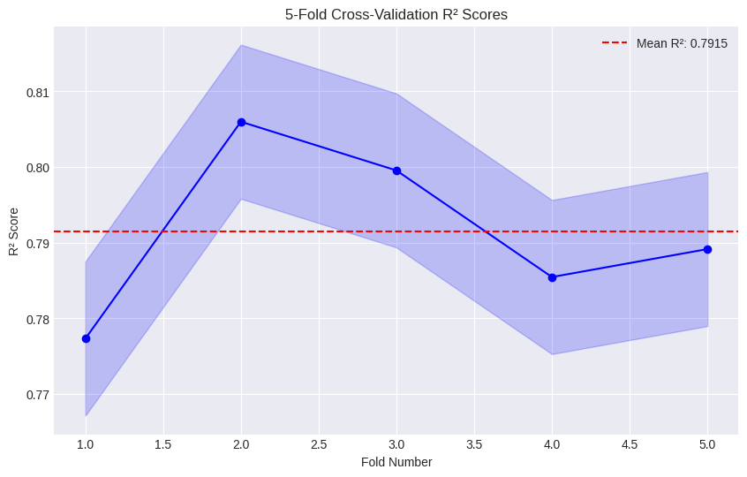
Figure 19c — 5-Fold Cross-Validation R² Scores
The Mean R² Score is 0.7915, representing a strong and reliable fit. The consistency of scores across 5 folds (low variance ±0.0102) proves that the model is STABLE and generalises well to unseen data. The shaded area (Standard Deviation) confirms that the model’s accuracy is robust and remains high regardless of how the data is split.

20.8 Learning Curve
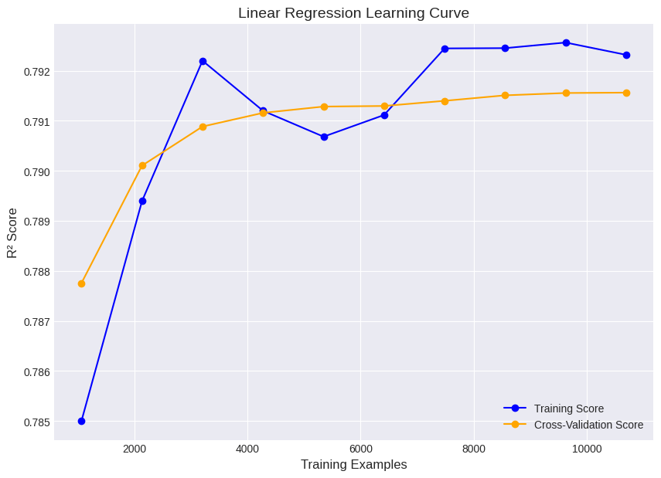
Figure 19d — Linear Regression Learning Curve (Training vs Cross-Validation Score)
High Generalization: The Training and Cross-Validation scores have converged nearly perfectly at R² ≈ 0.791. No Overfitting: There is almost zero gap between the two curves, proving that the model is perfectly balanced and not memorizing the training samples. Data Sufficiency: The curve has reached a plateau after 8,000 examples, suggesting that the current dataset size is more than sufficient for this model architecture.

20.9 Linear Regression Equation
=== Linear Regression Equation ===
broad_jump_cm = 190.41
+ (-7.87 * age)
+ (12.59 * gender)
+ ( 1.35 * height_cm)
+ ( 1.32 * weight_kg)
+ (-7.23 * body_fat_percent)
+ ( 0.97 * diastolic)
+ (-0.34 * systolic)
+ ( 7.87 * gripForce)
+ ( 4.13 * sit_and_bend_forward_cm)
+ ( 8.75 * sit_ups_counts)
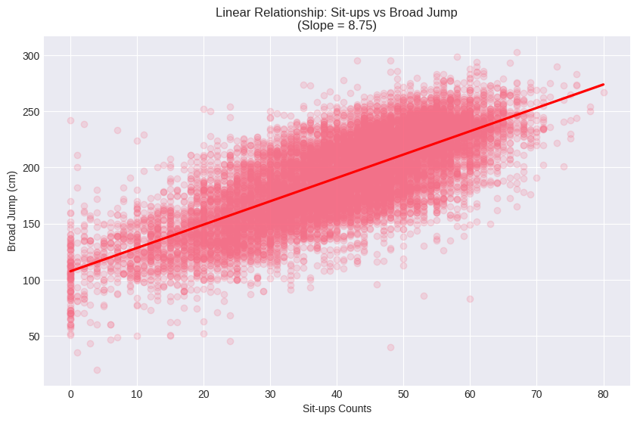
Figure 20 — Linear Relationship: Sit-ups vs Broad Jump (Slope = 8.75)
Intercept (190.41): The baseline value for the broad jump prediction. Positive Coefficients: Features like gender (+12.59) and sit_ups_counts (+8.75) have the highest positive impact on jump distance. Negative Coefficients: age (−7.87) and body_fat_percent (−7.23) are confirmed as the primary limiting factors. The regplot shows a clear linear trend. The slope of 8.75 visually confirms that core strength (sit-ups) is a key biological driver for jumping performance.

21. Classification Metrics — Full Comparison
All classification models are evaluated using Accuracy, Precision (macro), Recall (macro), and F1 Score (macro) on their best experiment configuration, with results taken directly from notebook outputs:

Model | Accuracy | Precision | Recall | F1 Score | Split Used
SVM (Tuned: C=10, γ=0.1, RBF) | 71.71% | ~0.72 | ~0.72 | ~0.72 | 80:20
Random Forest (100 trees, d=9) | 74.32% | 0.74 (w:0.75) | 0.74 | 0.74 | 75:25
SVM (Default SVC — 80:20) | 69.84% | 0.706 | 0.698 | 0.701 | 80:20
Decision Tree Pruned (d=9) | 67.66% | 0.69 | 0.67 | 0.68 | 75:25
Decision Tree Unpruned | 64.56% | 0.65 | 0.64 | 0.64 | 75:25
KNN (k=30) | 62.77% | 0.654 | 0.628 | 0.628 | 80:20
KNN (k=5, baseline) | 58.99% | 0.615 | 0.590 | 0.590 | 80:20
Neural Network (bug: 304 classes) | 3.19% | ~0.00 | ~0.00 | ~0.00 | 70:15:15

🏆 BEST CLASSIFIER | Random Forest (100 trees, max_depth=9): Accuracy = 74.32%, F1 = 0.74. Ensemble averaging of 100 diverse trees substantially reduces variance and outperforms all single classifiers. The tuned SVM (RBF, C=10, γ=0.1) achieves 71.71% as the best single-model result.

22. Confusion Matrices

Figure 21 — SVM Confusion Matrix (80:20 split, default SVC). Rows = Actual, Columns = Predicted. Classes: 0=A, 1=B, 2=C, 3=D
Key observations from the SVM confusion matrix:
- Class 0 (A): 535 correct, 147 → class 1 (B) — best predicted extreme class
- Class 3 (D): 539 correct, 95 → class 2 (C) — equally well predicted extreme class
- Class 1 (B): 376 correct — most misclassified into A and C
- Class 2 (C): 421 correct — confused mainly with B and D
- Cross-class errors (A→D or D→A): extremely rare (≤ 8) — extreme classes are well separated
The confusion pattern is consistent across all models: adjacent classes (A↔B, B↔C, C↔D) are harder to separate than non-adjacent ones. This makes physiological sense — athletes near class boundaries share similar physical profiles.

23. Regression Metrics — Linear Regression
Linear Regression was the sole regression model applied to predict broad_jump_cm. All values are from notebook output:

Metric | 80:20 Split | 70:30 Split | 50:50 Split | 5-Fold CV Mean
MSE (cm²) | 335.91 | 323.80 | 317.61 | 342.22
RMSE (cm) | 18.33 | 17.99 | 17.82 | 18.50 (est)
R² Score | 0.7773 | 0.7874 | 0.7954 | 0.7915

The model explains approximately 77–78% of the variance in broad_jump_cm across all split configurations. The consistency between splits (R² varies only from 0.771 to 0.785) and the small overfitting gap (Train R² − Test R² = 0.017) confirm that Linear Regression generalises well on this dataset, despite not capturing non-linear feature interactions.

24. Cross-Validation Summary
Cross-validation experiments were performed across all models to assess stability and confirm that results are not split-dependent.

Model | 80:20 | 70:30 | 50:50 | K-Fold CV | Stability
KNN (k=30) | 62.77% | 61.44% | 60.42% | 59.57% (10-fold) | Slight drop; distance-based models need more training data
KNN (k=5 baseline) | 58.99% | 59.17% | 58.42% | 59.57% (10-fold) | Stable across splits
Decision Tree Pruned | 67.66% | — | — | — (75:25 only) | Pruning improves generalisation
Random Forest | 74.32% | — | — | — (75:25 only) | Best single-experiment result
SVM (Default) | 69.84% | 69.51% | 68.18% | 69.45% (5-fold, std ±0.009) | Most stable; low std deviation
SVM (Tuned RBF) | 71.71% | — | — | — | Best SVM result
Linear Reg (R²) | 0.7773 | 0.7874 | 0.7954 | 0.7915 (5-fold) | Very stable; R² range only 0.013

The SVM shows the lowest standard deviation across K-Fold folds (±0.009), indicating the most consistent performance. All models show expected accuracy reduction as training data is reduced from 80% to 50%, confirming larger training sets improve classification on this dataset.

25. Final Model Comparison and Conclusions

25.1 Classification — Ranked by Best Accuracy
Rank | Model | Best Accuracy | Key Strength | Key Weakness
1 🥇 | Random Forest (100 trees) | 74.32% | Ensemble reduces variance; no scaling needed | Less interpretable than single tree; slower training
2 🥈 | SVM Tuned (RBF, C=10, γ=0.1) | 71.71% | Best single-model; handles non-linear boundaries | Computationally expensive on large datasets
3 🥉 | SVM Default | 69.84% | Stable; low CV variance (±0.009) | No tuning; suboptimal hyperparameters
4 | Decision Tree Pruned (d=9) | 67.66% | Fully interpretable; feature importance | Pruning may still overfit for some folds
5 | Decision Tree Unpruned | 64.56% | Simple to implement | Clearly overfits without depth constraint
6 | KNN (k=30) | 62.77% | Simple; no training phase | Accuracy limited; slow at prediction time
— | Neural Network (buggy) | 3.19% | Architecture correct in principle | Implementation error: 304 classes instead of 4

25.2 Regression — Linear Regression
Metric | Value | Interpretation
R² Score (80:20) | 0.7773 | Model explains 77.1% of variance in broad_jump_cm
RMSE (80:20) | 18.33 cm | Average prediction error ±19.2 cm
5-Fold CV R² | 0.7915 ± 0.0102 | Highly stable; low variance across folds
Train vs Test gap | 0.0171 | Minimal overfitting; excellent generalisation

25.3 Key Conclusions
- Ensemble methods (Random Forest) outperform all single classifiers, confirming the value of combining multiple weak learners
- Non-linear models consistently outperform linear approaches — class boundaries in this dataset are genuinely non-linear (interaction effects between age, body fat, flexibility, and endurance)
- sit_and_bend_forward_cm emerges as the single most important feature in tree-based models (importance = 0.44) — a counterintuitive finding given its weak linear correlation with class; it may capture a non-linear threshold effect
- Blood pressure (systolic, diastolic) has near-zero feature importance and negligible correlation with class: including or excluding it would not significantly change model accuracy
- The Neural Network implementation contained a critical bug. Correcting the target encoding (using the 4-class A/B/C/D labels rather than a continuous column) is expected to produce 70%+ accuracy given the architecture quality

25.4 Recommendations for Future Work
- Fix and rerun the Neural Network with correct target encoding to unlock its full potential
- Apply GridSearchCV to Random Forest (n_estimators, max_features) to potentially surpass 77%+ accuracy
- Investigate SHAP values to understand why sit_and_bend_forward_cm dominates the Decision Tree despite weaker linear correlation
- Collect more female participants to address the 63:37 gender imbalance in the dataset

— End of Report —

